OTT Platform Content Success Analysis

1. Introduction and Problem Statement
Understanding the performance of content on OTT platforms is essential for improving audience engagement, content strategy, and subscriber growth. This project focuses on analyzing Netflix content data to identify meaningful patterns related to content types, genres, ratings, countries of production, and growth trends.

2. Data Description
The dataset used in this project contains information about Netflix movies and TV shows available on the platform.
Dataset Characteristics:
- Total Records: ~8,800+
- Total Attributes: 12+ columns
Key Data Attributes:
- Content Information: title, type, duration, rating
- Time Information: release_year, date_added
- Category Information: listed_in (genre)
- Regional Information: country
- People Information: director, cast
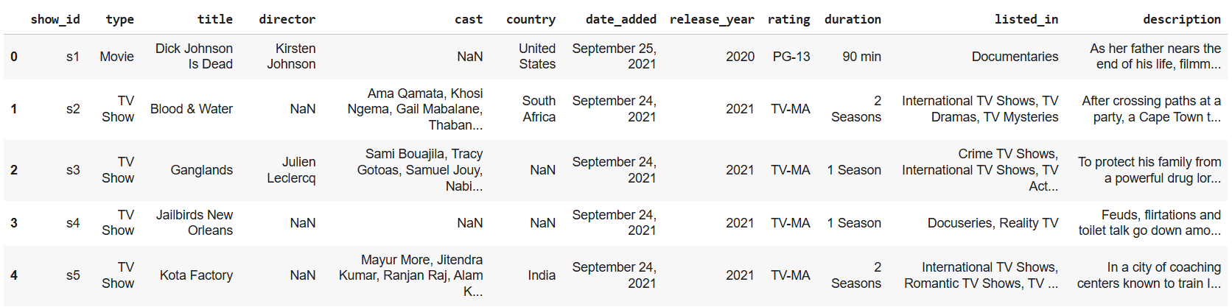

3. Data Cleaning and Preparation (Python)
Python was used as the primary tool for cleaning and preparing the dataset for analysis.

3.1 Initial Data Exploration
- Dataset loaded using Pandas
- Reviewed column types and summary statistics
- Identified missing and inconsistent values
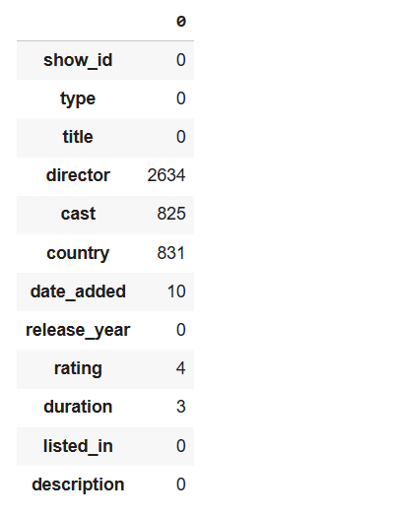

3.2 Handling Missing Values
- Missing director and cast replaced with "Unknown"
- Missing country replaced with "Unknown"
- Missing rating filled with the most frequent rating
- Missing date_added values retained (handled safely during analysis)
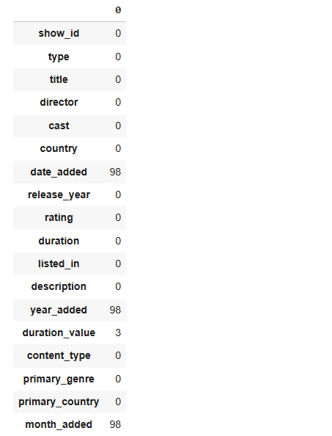

3.3 Feature Engineering
To enhance analytical depth, new features were created:
- year_added and month_added from date_added
- duration_value extracted from the duration column
- primary_genre extracted from listed_in
- primary_country extracted from country
4. Exploratory Data Analysis (EDA & KPI Analysis)
In this project, we performed an Exploratory Data Analysis (EDA) to gain insights into the OTT platform content. The following Key Performance Indicators (KPIs) were identified and analyzed:
- Total content count: We first calculated the total number of contents available on the platform to get an overall view of the dataset.
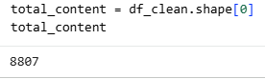
- Movies vs TV Shows distribution: Next, we analyzed the distribution between movies and TV shows to understand the platform’s content mix.
  - 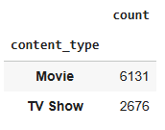
- Content growth over years: We examined the growth of content over the years to identify trends in content addition.
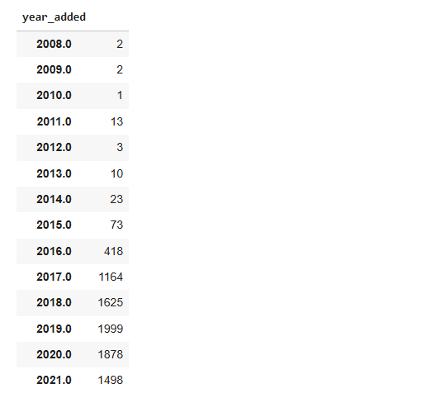
- Top 10 genres: We identified the most popular genres on the platform, providing insight into viewer preferences.
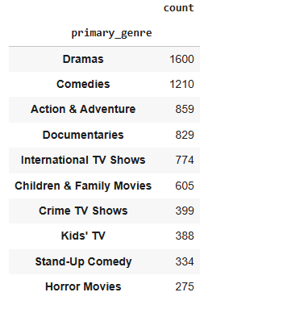
- Top 10 content-producing countries: We analyzed which countries contribute the most content, highlighting the platform’s global reach.
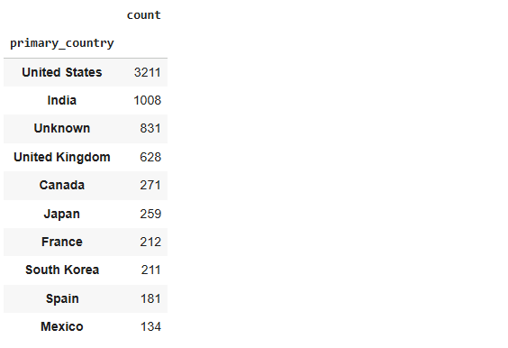
- Rating distribution: We studied the distribution of content ratings to understand how content is categorized for viewers.
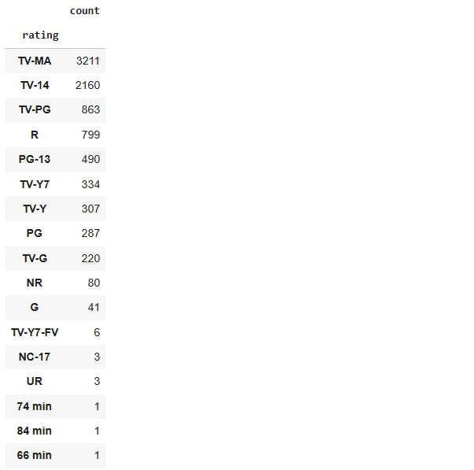
- Average movie duration: We calculated the average duration of movies to observe typical content lengths.
- Top release years: Finally, we identified the years with the highest number of releases to spot peak production periods.
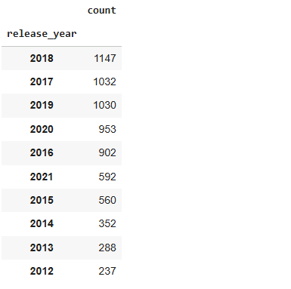

5. Data Visualization and Dashboard (Power BI)
An interactive dashboard was developed using Power BI to visually communicate insights to non-technical stakeholders.
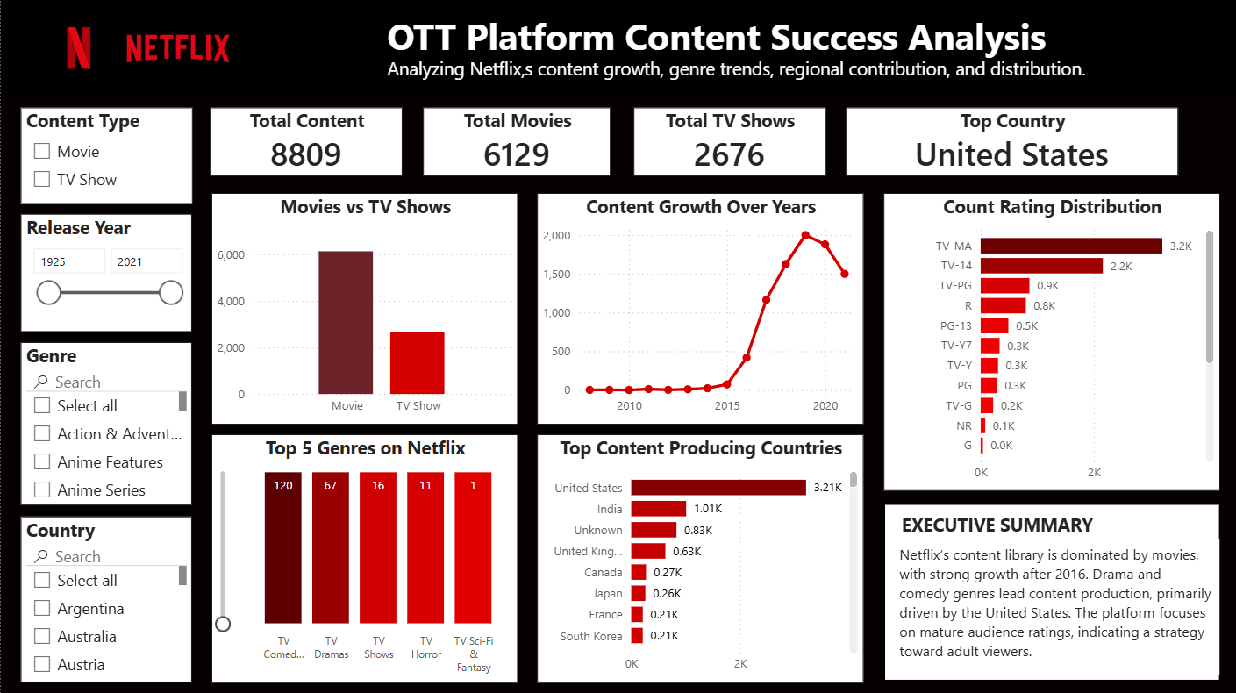

6. Key Insights and Business Recommendations
Insights:
- Movies dominate Netflix content library compared to TV Shows
- Significant content growth after 2016
- Drama and Comedy are the most common genres
- United States is the leading content producer
- Platform targets mature audiences (TV-MA, TV-14 ratings)
Recommendations:
- Focus content investment on top-performing genres
- Expand regional content beyond the US
- Maintain balance between movies and TV shows for subscriber retention
- Strategize content release timing based on historical growth trends
- Target marketing based on content ratings and popular genres

7. Conclusion
This project demonstrates how Netflix content data can be transformed into actionable business insights using Python for data cleaning, feature engineering, and KPI analysis, along with Power BI for interactive dashboards. The approach highlights real-world analytical skills relevant to Data Analyst and Business Analyst roles.

8. Tools and Technologies Used
- Python (Pandas, NumPy, Matplotlib, Seaborn)
- Google Colab
- Power BI
- CSV Dataset (Netflix)

9. Disclaimer
This project report is created for academic and portfolio purposes using publicly available data. The analysis does not represent official Netflix business metrics and is meant for learning and demonstration purposes.

